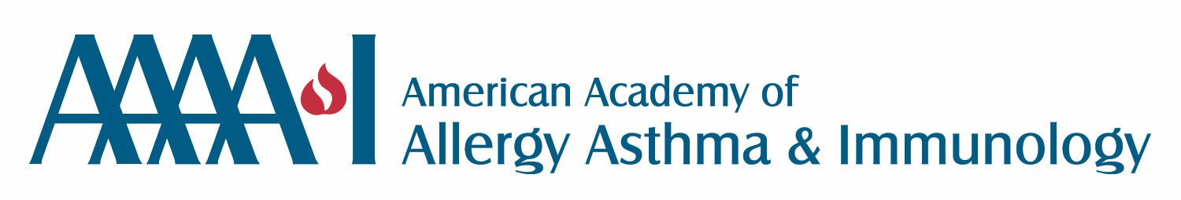

In response to a 2012 fungal meningitis outbreak, the Drug Quality and Security Act was adopted in November 2013, clarifying that the FDA has authority over compounding of human drugs. The FDA endorsed the United States Pharmacopaiea’s (USP) Pharmaceutical Compounding: Sterile Preparations guidelines as the standard to be followed for pharmaceutical compounding in most settings. As a result of a collaborative effort, the AAAAI, the ACAAI and the AAOA were able to obtain a partial exemption from the personnel, environmental and storage requirements for allergen extract preparation that apply under Chapter 797, which includes most sterile compounding under the USP, so long as a separate chapter specifically addressing appropriate procedures were followed for immunotherapy mixing.
Recently, the USP posted a proposed update to Chapter 797 of the USP, fundamentally changing the requirements for sterile compounding. Overall, it eliminates procedures based on three levels of products and the recognized level of risk they carry. Instead, it creates just two categories differentiated by new procedures required and the timeframe in which they are now allowed to be used. The updated document declares that no sterile compounding is inherently “low risk” and sets the tone for the severe changes made in the guidelines, including the complete elimination of a separate chapter for procedures for allergen extract mixing.
The more extensive procedures for mixing under the draft would make it highly unlikely that allergists would be able to continue to conduct allergen extract mixing in their own offices. Further, the proposed requirements would set an expiration date for allergen extract at just 42 days after mixing that would demand more frequent mixing of extract, threaten treatment progress, exposing patients to increased risk of allergic adverse events with the use of frequent vial changes, and greatly increase cost of care. The result of these changes would significantly reduce patient access to immunotherapy.
While the USP focus on patient safety is commendable, allergists have safely provided allergy immunotherapy services for more than 100 years, with zero reported cases of infectious complications related to the compounding and administration of subcutaneous allergen immunotherapy. That translates to millions of patients who have experienced improved overall health, reduced progression of allergic disease, and significantly improved quality of life thanks to immunotherapy.
Allergen immunotherapy is a proven disease modifying treatment that reduces personal and systemic healthcare costs by not just reducing symptoms, but diminishing the unwanted immunological response to allergic triggers. The proposed changes to the USP would significantly reduce patient access to this treatment, resulting in significant increases in the demand for healthcare resources to treat symptoms without modifying the allergic disease course.
The AAAAI urges you to participate in the public comment period on the draft USP Chapter 797. Inform them of the significant difference allergen immunotherapy has made in the lives of the patients in your practice. If you have patients who will personally attest to an improved quality of life thanks to your treatment, please invite them to participate in this public comment period as well.
For your reference, we have outlined three broad areas of concern for your consideration when you draft your response. It is important that all A/I physicians take the time to review the proposed 797 changes and contemplate the profound impact this will have on one’s ability to manage patients with allergic diseases. As physicians, it is our duty to be our patient’s strongest advocate and defend their access to an effective therapy that had been utilized to benefit patients for over a century.
To review the proposed revisions to General Chapter <797> Pharmaceutical Compounding—Sterile Preparations, click here. To submit comments in response to these proposed revisions, scroll down this webpage to download and save the “submission template,” to your desktop.
Your comments must note: section, line number, existing text and suggested change, your comment and rationale/scientific evidence (as pictured below). Email the submission template with your comments to: CompoundingSL@usp.org.
Comments will be accepted until January 31, 2016. If you have any questions about submitting comments, contact the Healthcare Quality Standards team at CompoundingSL@usp.org.
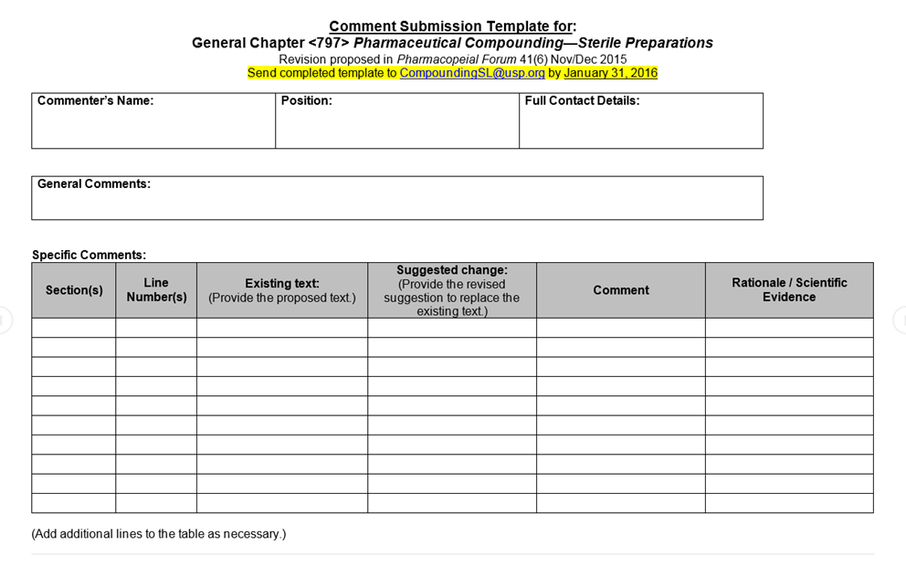
The impact of removing the ability of allergists to compound immunotherapy prescriptions in their office will have a profound effect upon patient care.
Next is the outline of FOUR broad areas of concern for your consideration when you draft your response.
ACCESS TO ALLERGEN IMMUNOTHERAPY (AIT):
Currently allergy immunotherapy compounding (AITC) is performed in numerous health settings that allows allergists to provide patient access to AIT.
-HEALTH SYSTEMS PHARMACIES AND OTHER CORPORATIONS MAY NOT/WILL NOT BE ABLE TO MEET THE PROPOSED REVISED USP REQUIREMENTS TO PERFORM AIT COMPOUNDING SERVICES.
- If healthcare systems pharmacies were able to meet the new USP AITC requirements these services will most likely be LIMITED TO EMPLOYED PHYSICIANS. This is an important point as the vast majority of allergists are not employed by healthcare systems - they may be on “staff” but are not employed. Compounding AIT for non-employed but affiliated physicians of healthcare facilities will not be feasible/permitted at these entities for a variety of reasons. Most importantly, if they were to provide AITC services for non-employed physicians then they would most likely be considered a manufacturer of AIT and would likely be subject to a variety of other state and federal regulations.
-NON HEALTHCARE SYSTEM EMPLOYED PHYSICIANS WILL HAVE LIMITED OPTIONS TO SECURE ALLERGY IMMUNOTHERAPY PRESCRIPTIONS FOR THEIR PATIENTS. Currently there are very limited options for AITC outside of the allergists’ office. Greer and Allergy Labs of Oklahoma are the only two facilities that have been identified as resources for this services in the United States.
-AITC BY OUTSIDE FACILITIES MAY LIMIT THE TIMELINES OF AIT TREATMENT. Currently Greer Labs has a 3-4 week waiting period from ordering of allergen extract and delivery. Stat service is available for a fee - but this would be a cost that would have to be borne by the patient and not reimbursable. It is not known if Greer labs or any other compounding facility would be able/willing to absorb additional allergy extract prescriptive service and be able to deliver this treatment in a timely fashion. This is compared to a physicians’ office performing AITC which could be make available the necessary treatment within hours to several days.
-Availability of AITC at just two facilities in the United States would make AITC problematic for a variety of reasons, most importantly the essential monopoly this would place on AITC and the lack of competition to mitigate the cost of AITC and the risk of access to AITC if there was a FDA regulatory issue.
-THE PROPOSED BEYOND USE DATE OF 42-45 DAYS FOR ALLERGEN EXTRACT VIAL CONTRADICTS CURRENT FDA GUIDELINES AND WILL MAKE AIT TREATMENT EXTREMITY DIFFICULT, INCREASE THE COST AND COULD FAIL TO ALLOW APPROPRIATE DOSE OF AIT TO BE ADMINISTERED. With current AIT administration practice, once the targeted full dose is reached, patients will then receive AIT every 2-4 weeks. When patients receive new vials of AIT current practice is to provide a half dose first and the following week to provide the full dose and then proceed to every 2-4 weeks maintenance schedule as ordered. The proposed 6 week expiration would require a patient to receive a new vial of AIT every 6 weeks: patients would receive a half dose one week, a full dose the following week then receive one to two more doses before a new vial would be needed and the whole process repeated. This has the potential to increase the number of AIT injections by 1/3, increasing the cost of care, reducing the effective dosing of AIT and placing the patient at increased risk for anaphylaxis to AIT.
COST OF ALLERGY CARE:
-MEDICARE DOES NOT COVER AIT MANUFACTURED BY A THIRD PARTY VENDOR. CPT CODE 95165, WHICH IS RECOGNIZED BY MEDICARE, IS FOR THE DIRECT PHYSICIAN SUPERVISION OF THE MAKING OF AIT EXTRACT. This code would not be applicable for AIT manufactured by outside source and the use of this code, by a physician or beneficiary to be reimbursed for AIT would constitute Medicare fraud.
-Commercial insurers recognize 95165 for reimbursement for AIT and, as with Medicare, it is not clear that there are any alternative CPT codes that they would recognize for reimbursement of AIT that is compounded outside of a physician’s office.
-The direct consequence of the USP not allowing the allergy exemption for AITC is that MEDICARE RECIPIENTS, AND POTENTIALLY COMMERCIALLY INSURED PATIENTS, WOULD NO LONGER HAVE AIT AS A COVERED SERVICE. USP WOULD BE EFFECTIVELY MAKING A MEDICAL POLICY DECISION THAT WOULD DIRECTLY NEGATIVELY IMPACT THE HEALTHCARE OF MEDICARE RECIPIENTS AND OTHERS. This potential change will directly transfer the cost of a previously covered benefit to the beneficiary.
-THE PROJECTED COSTS OF AIT WOULD INCREASE SIGNIFICANTLY AS A RESULT OF THESE CHANGES. An analysis based upon current Medicare billing requirement and reimbursements, reimbursement from Novitas (a major Medicare administrator) and charges of two third party vendors suggest the cost for an initial treatment set of AIT would be increased by 2.0 to 5.1-fold and for maintenance AIT this cost would increase from 1.4 to 4.2-fold. This is per one treatment vial. This analysis is also based upon the current practices of these companies following current USP 797 Allergy exemption guidelines. It is not clear that if the proposed guidelines were to be implemented that these costs would remain the same. Given the proposed requirement for sterility testing we would expect these costs to increase even further.
-The above potential impact will have other DOWNSTREAM SIGNIFICANT HEALTHCARE AND ECONOMIC IMPACTS ON THE HEALTHCARE SYSTEM IN THE UNITED STATES.
-At the most basic level the projected INCREASED COST OF AIT WILL SIGNIFICANTLY DECREASE ITS VALUE (RECALL VALUE = QUALITY/COST). THIS IS IN DIRECT OPPOSITION TO THE CURRENT GOVERNMENT MANDATES TO INCREASE THE VALUE OF HEALTH CARE.
-AIT has long been known to prevent the development of sensitization (allergy) to new allergens and, depending upon when AIT is instituted, prevent the development of other allergic diseases such as asthma. It is very difficult to put an economic value on this, but certainly DENYING PEDIATRIC PATIENTS WITH ALLERGIC RHINITIS THE OPPORTUNITY TO HAVE ACCESS TO AIT INCREASES THE RISK FOR THE DEVELOPMENT OF MORE ALLERGIC DISEASES THAT WILL BURDEN THE HEALTHCARE SYSTEM. THIS WILL ACCELERATE THE INCREASED COST OF HEALTHCARE.
-AIT HAS BEEN DEMONSTRATED TO SIGNIFICANTLY REDUCE OVERALL HEALTHCARE COSTS, OUTPATIENT MEDICAL COST, AND PHARMACY COSTS IN A FLORIDA MEDICAID POPULATION. Perhaps most profound in this population, the use of AIT was found to significantly reduce in-patient admissions and very importantly reduced inpatient hospitalization costs from $2441 to $1! These data are profound statements on the impact that AIT has on improving patient care as well as healthcare costs. IF AITC WERE TO BECOME SEVERELY RESTRICTED, THESE DATA VERY STRONGLY SUGGEST THAT THIS WILL HAVE VERY SIGNIFICANT HEALTHCARE IMPACT ON SOME OF THE MOST VULNERABLE PATIENTS AND HEALTHCARE ECONOMIC IMPLICATIONS THAT COULD RUN INTO BILLIONS OF DOLLARS.
SAFETY OF ALLERGEN IMMUNOTHERAPY
- AIT HAS BEEN PRACTICED FOR OVER 100 YEARS AND THERE HAS BEEN NO REPORTED CASES IN THE PEER REVIEWED MEDICAL LITERATURE THAT PREVIOUS AITC PRACTICE NOR THE CURRENT AITC PRACTICES FOLLOWING USP 797 WITH THE ALLERGY EXEMPTION HAS CAUSED PATIENTS TO DEVELOP AN INFECTIOUS DISEASE. IN OTHER WORDS THERE HAS BEEN NO SENTINEL EVENT THAT JUSTIFIES THE PROPOSED CHANGES TO AITC. THE RESPONSE OF USP TO A NON EVENT IS OUT OF PROPORTION AND IN FACT THE PROPOSED CHANGES POTENTIALLY WILL PLACE PATIENTS AT RISK FOR SEVERE AND POSSIBLY LIFE THREATENING ALLERGIC REACTIONS - IN ORDER TO PREVENT POSSIBLE INFECTIOUS COMPLICATIONS THAT TO DATE HAVE NOT BEEN DOCUMENTED.
-There have been data reported in the peer-reviewed medical literature that AITC as currently practiced does not place patients at risk for infectious complications. We acknowledge that these studies have not been ideally designed and have methodologic flaws.
-IT IS OF CONCERN THAT USP, THE FDA AND/OR OTHER ORGANIZATIONS HAVE HELD PRIVATE CONCERNS ABOUT THE SAFETY OF AITC REGARDING THE POTENTIAL FOR INFECTIOUS COMPLICATIONS AND HAVE FAILED TO CONVEY THESE CONCERNS IN A TIMELY MANNER TO THE A/I COMMUNITY. IF THIS WERE DONE, APPROPRIATELY DONE PROSPECTIVE STUDIES COULD HAVE BEEN DONE TO ADDRESS THEIR CONCERNS.
CONCERNS ABOUT ANAPHYLAXIS
-Any discussion of AIT and AITC must recognize the primary risk of AIT is anaphylaxis and death. The risk of death from AIT is estimated to be 1:2.4 - 1: 2.6 millions dose. AS NO INFECTIOUS COMPLICATIONS HAVE BEEN REPORTED OR DOCUMENTED IN THE PUBLISHED LITERATURE WHILE THE RISK OF SEVERE AND POSSIBLY LIFE THREATENING ALLERGIC REACTION IS THE PRIMARY SAFETY CONCERN FOR AIT AND AITC.
-Obviously with the administration of AIT there is a risk of anaphylaxis. The management of a patient who had an untoward allergic reaction to AIT includes dosage adjustment of the AIT. Typically, this would be a 1:10 v/v or more dilution down from the vial that the patient experienced a reaction to. Under the current guidelines this could easily be done in the office setting. With the proposed recommendations, this would no longer be permissible in the office and would require a new AIT prescription to be sent to an outside company. The cost of this would most likely not be covered by Medicare or other third party insurers and, as noted above, it would take almost a month for the new AIT vial(s) to be delivered. This process would further increase the cost of AIT, delay care and place the patient at increased risk for anaphylaxis because of the interruption of AIT treatment.
-With AIT treatment, patients are not always compliant with treatment schedules and at times will require dosage adjustments that would require dilutions of AIT treatment vials to be made. As above, this could typically be done in the office setting but the proposed changes to USP 797 would cause delays in care and place the patient at increased risk of anaphylaxis.
-With AIT, one of the risks of anaphylaxis comes from changing allergen source. Most allergen extracts are not standardized and there is variable content of the actual allergen within each bottle. Accordingly, there may be significant variation in allergen content from lot number to lot number within the allergen extract source and between allergen extract source. As currently practiced, AITC performed in physician offices clearly controls the source of allergens and is fully aware if there is a change in vendor source for AIT reagents and if the vendor may have changed currently used extracts. As a result of this, the physician is able to immediately make adjustments to the AIT treatment plan to mitigate the risk of anaphylaxis for the patient. If AITC is moved to outside vendors, there is no mechanism in place to control for any of these possible scenarios and this will place the patient on AIT at significant risk for anaphylaxis from AIT.
- WITH AIT THERE IS AN INCREASED RISK OF ANAPHYLAXIS FROM NEWLY PREPARED AIT VIALS. AS DISCUSSED ABOVE THE PROPOSED CHANGES IN USP 797 WOULD SUBSTANTIALLY INCREASE THE NUMBER OF NEW VIALS OF ATIC AND PLACE PATIENTS AT INCREASED RISK FOR SEVERE AND POSSIBLY LIFE THREATENING ALLERGIC REACTIONS.

Cost Comparison of AIT between Third Party Supplies and Medicare Administrator

—————————-Greer————————————-
< 6 Antigens 7-12 Antigens 13-15Antigens Allergy Labs OK Novitas
5ml B/U 204.50 (3.4) 231.94 (3.8) 308.75 (5.1) 121.54 (2.0) 60.75
5ml Maint 148.09 (2.4) 159.15 (2.6) 255.16 (4.2) 87.55 (1.4) 60.75
( ) multiple cost compared to Medicare
Medicare reimburse 1 dose is 1 cc, so 5ml vial would be 5 dose. Assumes Medicare carrier will pay $12.15 per dose, participating provider in an outpatient setting. If this was at a facility the reimbursement would be $3.17 and the multiple cost compared to Medicare reimbursement would multiple by a factor of 3.8
SUMMARY:
-WE RESPECT USP CONCERNS ABOUT THE SAFETY OF AITC AS RELATED TO INFECTIONS. HOWEVER THERE ARE NO DATA TO SUPPORT THE RISK OF INFECTION FROM AITC AS CURRENTLY DONE UNDER USP 797 WITH THE ALLERGY EXEMPTION.
-THERE ARE NO DATA THAT THE PROPOSED GUIDELINES WILL LOWER THE RISK OF INFECTIONS COMPLICATIONS (WHICH HAVE NEVER BEEN DOCUMENTED) AND IN FACT THESE PROPOSED CHANGES TO USP 797 WILL PLACE PATIENTS AT INCREASED RISK FOR SEVERE ALLERGIC REACTIONS ( ANAPHYLAXIS AND DEATH), WILL DECREASE ACCESS TO AIT AND INCREASE HEALTHCARE COSTS.
REQUEST:
-MAINTAIN CURRENT USP 797 GUIDELINES WITH THE ALLERGY EXEMPTION IN PLACE IN ORDER TO PRESERVE PATIENT ACCESS TO A PROVEN TREATMENT THAT IMPROVES PATIENT CARE, DECREASES HEALTHCARE UTILIZATION AND COST, AND PREVENTS DEVELOPMENT OF NEW ALLERGIC SENSITIZATIONS AND ALLERGIC DISEASES SUCH AS ASTHMA.
-AS STATED IN USP MONOGRAPH “QUALITY STANDARDS FOR COMPOUNDED PREPARATIONS” THAT “USP WILL CONTINUE TO ENGAGE STAKEHOLDERS— INCLUDING PRACTITIONERS, MEMBER ORGANIZATIONS, AND REGULATORY ENTITIES— AND WORK TO EXPAND THE REACH OF OUR PUBLIC HEALTH IMPACT. WE WILL MAKE INVESTMENTS IN HEALTHCARE QUALITY AND SAFETY/COMPOUNDING PROGRAMS—TAILORING OUR OFFERINGS TO MEET UNIQUE STAKEHOLDER AND CUSTOMER NEEDS.” WE REQUEST THAT USP CONTINUES TO REACH OUT TO AAAAI, ACAAI, AAOA-HNS, PATIENTS AND PATIENT ADVOCACY GROUPS TO CONTINUE DISCUSSION TO ENSURE THE SAFE CONVENIENT ACCESS TO AIT.

