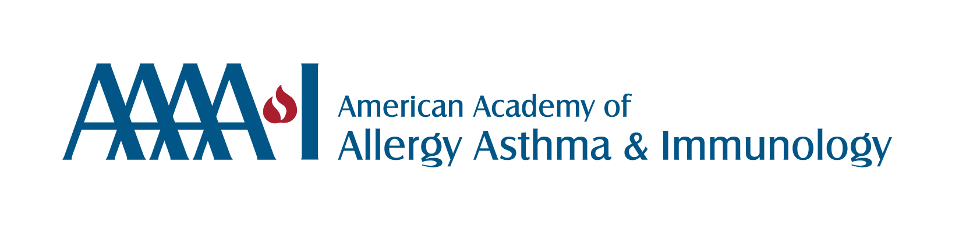

**Protect NIH / Protect Patients Toolkit: Letter to Congress Template**

Dear [*Representative/Senator] [Last Name],*

As a *[physician/researcher]* and member of the American Academy of Allergy, Asthma & Immunology (AAAAI), I’m writing from [City, State] to urge you to take immediate action to protect NIH funding — and with it, the future of patient care, medical innovation and physician training in our specialty and healthcare workforce development.

Since January 2025, over $1.5 billion in NIH funds have been frozen. Proposed cuts to facilities & administrative (F&A) support threaten the infrastructure essential for safe, effective research.

NIH investment has led to major progress in understanding and treating asthma, food allergies, atopic dermatitis (eczema) and immune deficiencies. It powers clinical trials, supports life-changing therapies and trains the next generation of allergists — many of whom serve rural and underserved areas.

In my role as *[Your Title/Position],* I’ve seen the impact of NIH-supported research firsthand. *[Insert 2–3 sentences: Share how your patients, research, institution, or training have benefited from NIH funding.]*

Without urgent action, we risk halting trials, losing research momentum, worsening the workforce shortage and widening health disparities. NIH funding also supports 400,000+ jobs and fuels a $1.5 trillion biomedical industry — every $1 invested yields $2.46 in economic activity.

I urge you to:

* Release frozen NIH funds immediately
* Oppose cuts to F&A support
* Ensure robust, sustained NIH funding in the FY25 budget and beyond
* Maintain the National Institute of Allergy and Infectious Disease as a single unit within the NIH, rather than creating three separate agencies.

Thank you for your leadership and commitment to public health.

Sincerely,

*[Your Name]*

*[Your Credentials/Title]*

*[City, State]*

*[Institution – optional]*

*[Email – optional]*

4/25